# Exchange Portal Proposal

## Summary

This proposal describes the benefits, costs and approach to completing the Exchange Portal.

The Exchange Portal tool would be used on Connectivity Location projects to compare datacentre or co-location choices and generate the maps required on these projects. It’s estimated it could save several man days for each Connectivity Latency project. Also it could be used a pre-sales tool.

The first release of the Portal would be used by Citihub consultants on client projects. In the future, if clients wanted to use the Portal then it could be extended to support this.

Secondly, the Portal would be a consolidated database of datacentre, venue and other related information that can be easily updated and then mined for use on client projects. This data is currently fragmented in a number of different spreadsheets.

## Current State

A working prototype of the tool has been built, see below is a screenshot. This prototype needs further development work, testing, security, documentation and rolled out internally. It is estimated that 15 days are required to complete these tasks.

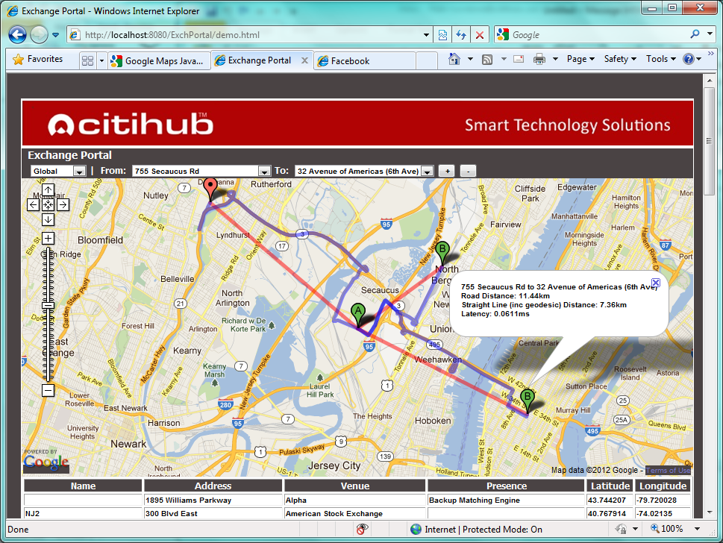

## Requirements for first release

The requirements for the first release of the tool are:

* Ability to create diagrams showing datacentre locations
* Export of data and diagrams to be used in a Client report
* Create a database of datacentre and venue information that can be easily maintained

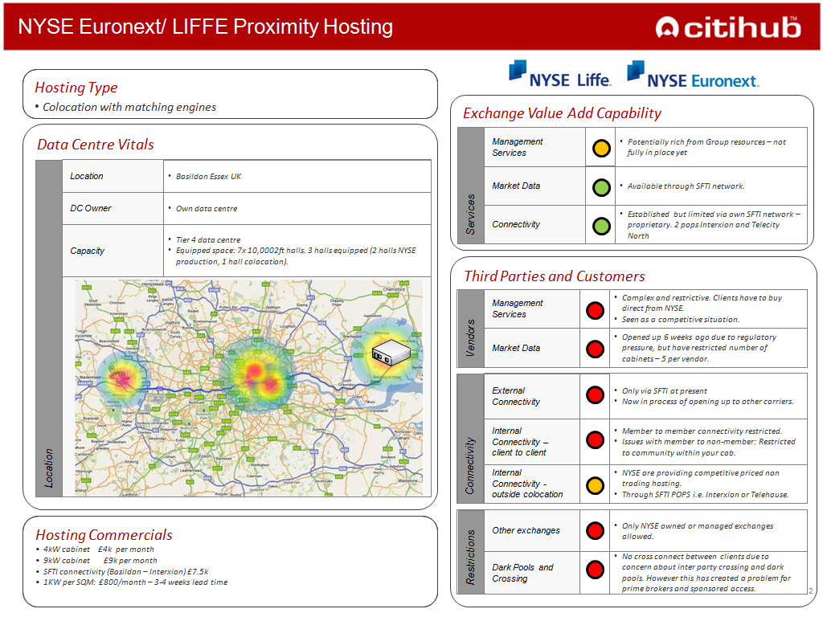

*Example report that will use a diagram from the Exchange Portal*

Areas that are out of scope for the first release:

* Use by non-Citihub staff
* Generation of Ex Conn diagrams to calculate optimal datacentre location
* Fiber routes

To avoid any client confidentiality issues, it will be possible to add of bank specific datacenters in an anonymous fashion, i.e. “Croydon DC”. Venue information is public domain so there will be no confidentially issue.

## Approach

The architecture of the solution will be as follows:

Web

Browser

App Server

Database

Excel

“Bulk Import”

Excel

Export

The MySQL Database and Tomcat server run in the Amazon Cloud on Linux.

## Plan

The remaining tasks to complete to finish a first release of the tool are:

1. Look and feel changes
2. Import all existing data from spreadsheets into the database and cleanse it
3. Security changes
4. Test harness
5. Complete add, amend and delete screens
6. User Guide
7. Operator manual
8. Export to Excel function
9. Backup strategy

## Resourcing

The following resources are required:

|  |  |  |
| --- | --- | --- |
| **Task** | **Duration** | **Who?** |
| HTML and Javascript developer | 13 days | Ian Tivey, Matt Vanstone |
| Data loading, clean up and web site testing | 2 days | Any consultant |
| ***Total*** | ***15 days*** |  |